Answers to questions on reading guide

Text 1

|  |  |  |  |  |
| --- | --- | --- | --- | --- |
| 1. A | 2. B | 3. D | 4. C | 5. A |
| 6 - | 7. D | 8. D | 9. D |  |

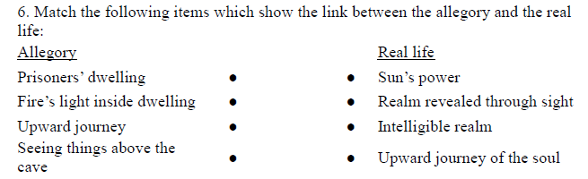

Text 2

|  |  |  |  |  |
| --- | --- | --- | --- | --- |
| 1. A | 2. A | 3. D | 4. F | 5. F |
| 6. B | 7. The shape of the statue. | | | 8. F |
| 9. F | 10. C | 11. F | 12. T | 13. T |
| 14. F | 15. T | 16. F | 17. A | 18. D |
| 19. F | 20. A | 21. C |  |  |

Text 3:

1. F

2.T (Change Aristotle to Galileo)

3.T

4. b

5. b

6. T

7. T

8. T

9. b

10. F

11. F

12. T

13. c

Text 4:

1. d
2. c
3. a
4. d
5. d
6. b
7. c
8. a
9. c
10. a
11. d
12. c

13. d

14. c

Text 5

Watson:

1. a

2. d

3. a

4. a

5. T

6. d

7. d

8. T

9. b

10.c

11. F

12. a

13. T

14. F

15. d

16. F

17. c

18. a

19. b

20. d

21. T

22. c

23. T

24. F

25. d

26. c

27. c

28. a

29. c

30. T

31. b

32. a

33. c

Text 6 Carson:

1. F

2. c

3. d

4. b

5. d

6. d

7. a

8. d

9. c

10. d

11. b

12. a

13. d

14. T

15. b

16. a

17. c

Text 7 Answer:

1. a;

2. c;

3. a;

4. d;

5. b;

6. b;

7. b;

8. a;

9. d;

10. b;

11. c;

12. a;

13. c;

14.

15.

16. d;

17. b;

18. T

19. D;

20. F;

21. T.

Text 8:

1. Superego; Id; Ego;

(a) By psychoanalysis;

4. c;

5. b;

6. I&V;

7. Cannot; is no; can;

8. a;

9.b;

10. c;

11. cortex; thalamus; claustrum;

12. c;

13. d;

14. a;

15. T;

16. F;

17. F;

18. T;

19. T;

20. F;

21. b;

22. b.

Text 9

1. F 2.F 3.a 4.F 5.T 6.b 7.c 8.d 9.b 10.T 11.d 12.T 13.F 14.d 15.F 16.F

Text 10

1.a 2.d 3.b 4.a 5.b 6.c 7.b 8.T 9.F 10.d 11.d 12.b 13.b 14.c 15.c 16.F 17.F 18.b 19.d 20.F 21.a 22.T 23.F 24.F 25.F

Text 11

|  |  |  |  |  |
| --- | --- | --- | --- | --- |
| 1. T | 2. F | 3. F | 4. A | 5. C |
| 6. D | 7. D | 8. F | 9. F | 10. F |
| 11. C |  |  |  |  |